LR SET #176
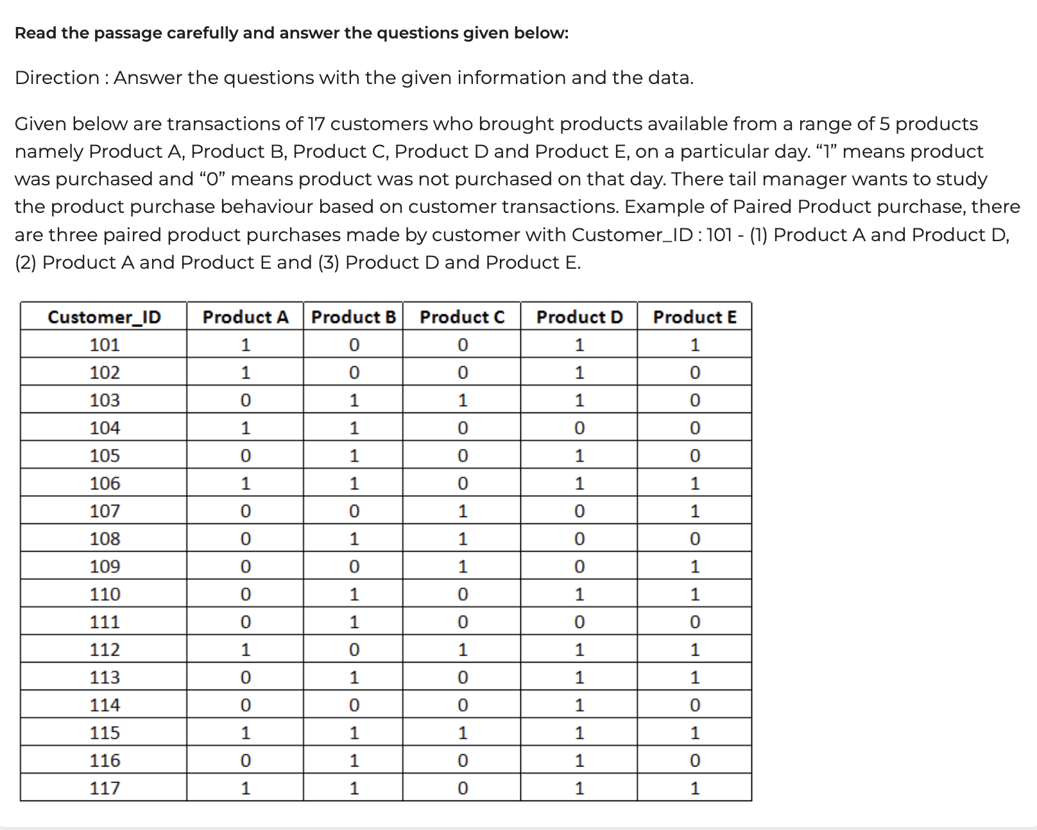
Here are the questions rewritten for clarity and correct grammar:

Question 1
How many paired product purchases include Product A as one of the two products?
A. 16
B. 17
C. 18
D. 19

Question 2
Assume the profit margins of the products are as follows: Product A – ₹50, Product B – ₹45, Product C – ₹60, Product D – ₹40, and Product E – ₹70. Based on the existing purchase frequency, which of the following product pairs generates the highest total profit margin?
A. Product A and Product D
B. Product A and Product E
C. Product B and Product D
D. Product B and Product E

Question 3
Given the same profit margins — Product A – ₹50, Product B – ₹45, Product C – ₹60, Product D – ₹40, and Product E – ₹70 — suppose the retailer offers a discount whenever a customer buys more than two products. The discount equals 10% of the margin of the higher-margin product in that combination. Based on this, how many customers in the sample data generate a total profit margin of ₹150 or more?
A. 4
B. 5
C. 6
D. 7

Question 4
How many customers purchased both the lowest-selling product pair and the highest-selling product pair?
A. 2
B. 0
C. 1
D. 3

VENN Diagram (Date: 21/09/2026 SET #186)

Scenario
450 students participated in a college festival featuring exactly four sports competitions — Cricket, Football, Badminton, and Hockey. Each student could choose any number of these four competitions.
Given information:
- Total students who chose Cricket = 195
- Total students who chose Football = 185
- Total students who chose Badminton = 180
- Total students who chose Hockey = 210
- The difference between the number of students who chose exactly three sports and those who chose all four sports = 40
- Students who chose only one sport: Cricket = 60, Football = 30, Badminton = 40, Hockey = 70

Question 1
What is the total number of students who chose exactly two sports?
A) 130 B) 150 C) 170 D) 190
Answer: D) 190

Question 2
How many students chose all four sports in the college festival?
A) 10 B) 20 C) 30 D) Cannot be determined
Answer: A) 10

Question 3
The number of students who chose at least three sports is what percentage of the total number of students?
A) 10% B) 15% C) 13.33% D) 16.67%
Answer: C) 13.33%
(Exactly 3 + All 4 = 50 + 10 = 60; 60/450 = 13.33%)

Question 4
If students who chose exactly 2 sports earlier also choose cricket now, what is the maximum percentage increase in the number of people who choose cricket?
A) 50% B) 53% C) 56% D) 59%
Answer: D) 59%

Full Solution Walkthrough
Step 1 — Exactly-1 sport:
$$E_1 = 60+30+40+70 = 200$$
Step 2 — Total headcount equation:
$$E_1+E_2+E_3+E_4=450 \Rightarrow E_2+E_3+E_4=250 \quad (A)$$
Step 3 — Weighted-sum equation (sum of individual sport totals; each student counted once per sport chosen):
$$195+185+180+210=770$$
$$1(E_1)+2(E_2)+3(E_3)+4(E_4)=770$$
$$200+2E_2+3E_3+4E_4=770 \Rightarrow 2E_2+3E_3+4E_4=570 \quad (B)$$
Step 4 — Eliminate $E_2$: $(B) - 2\times(A)$:
$$E_3+2E_4=70 \quad (C)$$
Step 5 — Use given condition $E_3-E_4=40 \Rightarrow E_3=E_4+40$. Substitute into (C):
$$(E_4+40)+2E_4=70 \Rightarrow 3E_4=30 \Rightarrow E_4=10,\ E_3=50$$
Step 6 — Solve for $E_2$ from (A):
$$E_2+50+10=250 \Rightarrow E_2=190$$
Result table:
Category | Count
Exactly 1 | 200
Exactly 2 | 190
Exactly 3 | 50
All 4 | 10
Verification: $200+190+50+10=450$ ✓ and $200+2(190)+3(50)+4(10)=770$ ✓

Step 7 — Question 4 (Maximum cricket increase):
Let the six exactly-2 pairs be CF, CB, CH, FB, FH, BH (sum = 190), and the four exactly-3 triples be CFB, CFH, CBH, FBH (sum = 50).
From the Cricket total equation:
$$60 + (CF+CB+CH) + (CFB+CFH+CBH) + 10 = 195$$
$$(CF+CB+CH)+(CFB+CFH+CBH)=125$$
New cricket count $= 195 + \big[190-(CF+CB+CH)\big]$ — this is maximized when $(CF+CB+CH)$ is minimized.
Since $(CFB+CFH+CBH)$ can be at most 50 (its ceiling, using up the entire triples pool, leaving FBH = 0):
$$(CF+CB+CH)_{min} = 125-50=75$$
So the maximum number of new cricket entrants $= 190-75=115$.
New cricket total $= 195+115=310$
$$\text{Max % increase} = \frac{115}{195}\times100% \approx 58.97% \approx \boxed{59%}$$

